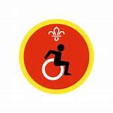
Once you have finished these worksheets you can post them back to Akela at 8, Smugglers Way or email them to 29thrikki@gmail.com and we will post your badge back to you.
Think about a public building that you are familiar with, maybe school, the library, the swimming baths etc and list all the adjustments that have been made to make it more accessible to people with a disability.
Can you think of another invention that maybe helpful
Disability Badge
Write a short message to a family member using braille and ask them to translate it.
Write your full name in braille;
Braille is a language used by people with a sight disability. It uses raised dots in a pattern to represent letters.Go around your home and list 6 items that have braille on them;
1.
2
3
4
5
6

Disability Badge

